44. A child slides down a hill on a toboggan with an acceleration of If she starts at rest, how far has she traveled in (a) 1.0 s, (b) 2.0 s, and (c) 3.0 s?
45. On a ride called the Detonator at Worlds of Fun in Kansas City, passengers accelerate straight downward from rest to 45 mi/h in 2.2 seconds. What is the average acceleration of the passengers on this ride?
67. Michael Jordan’s vertical leap is reported to be 48 inches. What is his takeoff speed? Give your answer in meters per second.
78. Standing at the edge of a cliff 32.5 m high, you drop a ball. Later, you throw a second ball downward with an initial speed of 11.0 m/s. (a) Which ball has the greater increase in speed when it reaches the base of the cliff, or do both balls speed up by the same amount? (b) Verify your answer to part (a) with a calculation.
79. You shoot an arrow into the air. Two seconds later (2.00 s) the arrow has gone straight upward to a height of 30.0 m above its launch point. (a) What was the arrow’s initial speed? (b) How long did it take for the arrow to first reach a height of 15.0 m above its launch point?
81. A hot-air balloon is descending at a rate of 2.0 m/s when a passenger drops a camera. If the camera is 45 m above the ground when it is dropped, (a) how long does it take for the camera to reach the ground, and (b) what is its velocity just before it lands? Let upward be the positive direction for this problem.
83. A model rocket blasts off and moves upward with an acceleration of until it reaches a height of 26 m, at which point its engine shuts off and it continues its flight in free fall. (a) What is the maximum height attained by the rocket? (b) What is the speed of the rocket just before it hits the ground? (c) What is the total duration of the rocket’s flight?

89. Geologists have learned of periods in the past when the Strait of Gibraltar closed off, and the Mediterranean Sea dried out and become a desert. Later, when the strait reopened, a massive saltwater waterfall was created. According to geologists, the water in this waterfall was supersonic; that is, it fell with speeds in excess of the speed of sound. Ignoring air resistance, what is the minimum height necessary to create a supersonic waterfall? (The speed of sound may be taken to be 340 m/s.)
90. Astronauts on a distant planet throw a rock straight upward and record its motion with a video camera. After digitizing their video, they are able to produce the graph of height, y, versus time, t, shown in Figure 2–36. (a) What is the acceleration of gravity on this planet? (b) What was the initial speed of the rock?
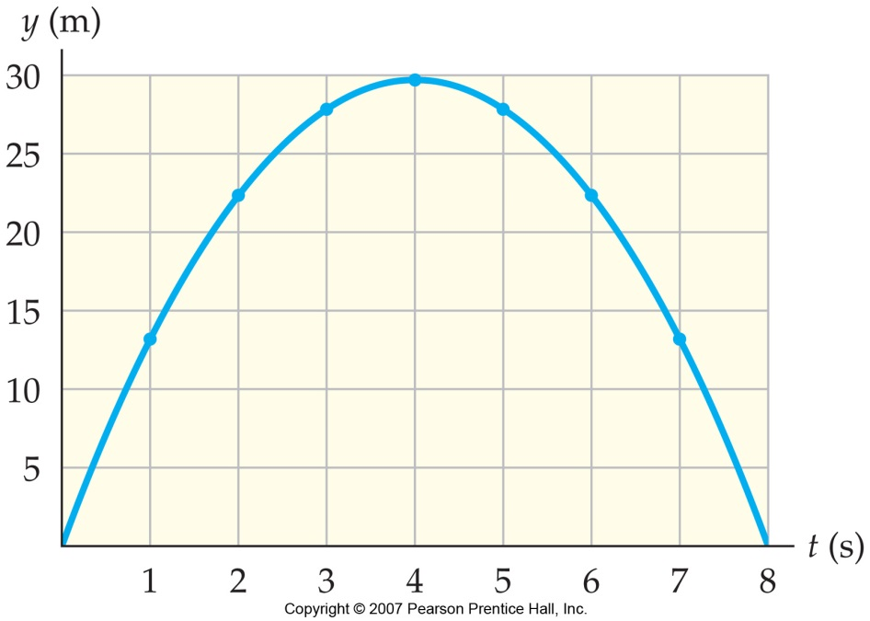
91. Bam! The first word spoken on the surface of the Moon after Apollo 15 landed on July 30, 1971, was “Bam!” The reason for this was that the rocket engine was shut off a bit early, when the lander was still 4.3 ft above the lunar surface and moving downward with a speed of 0.50 ft/s. From that point on the lander descended in lunar free fall. (a) What was the impact speed when the lander touched down? Give your answer in feet per second, the units used by the astronauts. (b) How long did it take for the lander to drop the last 4.3 ft? (The acceleration of gravity on the Moon is )
Figure 2-36
Problem 90
93. A youngster bounces straight up and down on a trampoline. Suppose she doubles her initial speed from 2.0 m/s to 4.0 m/s. (a) By what factor does her time in the air increase? (b) By what factor does her maximum height increase? (c) Verify your answers to parts (a) and (b) with an explicit calculation.
94. At the 18th green of the U. S. Open you need to make a 20.5 ft putt to win the tournament. When you hit the ball, giving it an initial speed of 1.57 m/s, it stops 6.00 ft short of the hole. (a) Assuming the deceleration caused by the grass is constant, what should the initial speed have been to just make the putt? (b) What initial speed do you need to make the remaining 6.00-ft putt?
97. A glaucous-winged gull, ascending straight upward at 5.20 m/s, drops a shell when it is 12.5 m above the ground. (a) What is the magnitude and direction of the shell’s acceleration just after it is released? (b) Find the maximum height above the ground reached by the shell. (c) How long does it take for the shell to reach the ground? (d) What is the speed of the shell at this time?
101. Old Faithful Watching Old Faithful erupt, you notice that it takes a time t for water to emerge from the base of the geyser and reach its maximum height. (a) What is the height of the geyser, and (b) what is the initial speed of the water? Evaluate your expressions for (c) the height and (d) the initial speed for a measured time of 1.65 s

