Teacher: Thomas Yawn 9th grade Physical Science

Class size: 23-28 students

Unit & Lesson Title: Kinetic Theory / Got Gas?

Lesson Objectives:

-The student will be able to correctly recall the three properties of gases with minimal cues from the instructor or classmate.
-The student will be able to demonstrate accurate understanding of gas behaviors by completing a concept map explaining Boyle’s law, Charles’ Law, and Gay-Lussac’s Law using information they gain from their textbooks and the lab stations they go to.
-The student will be able to create a qualitative graph relating the temperature and pressure of a gas, temperature and volume of a gas, and pressure and volume of a gas by labeling both x and y axes and having the correct slope after observing how a gas responds to manipulating those two variables.

Standards:
SPS5. Students will compare and contrast the phases of matter as they relate to atomic and molecular motion.
- Relate temperature, pressure, and volume of gases to the behavior of gases.
SCSh2. Students will use standard safety practices for all classroom laboratory and field investigations.
a. Follow correct procedures for use of scientific apparatus.
SCSh3. Students will identify and investigate problems scientifically.
e. Develop reasonable conclusions based on data collected.
f. Evaluate whether conclusions are reasonable by reviewing the process and checking against other available information.

Overview:
This is a student focused lesson lasting two 50 minute class periods which introduces learners to gases and their behaviors. Students will rotate through multiple stations in small groups conducting hands on “experiments” and recording their observations. At each station, the students will be investigating how the volume, pressure, and temperature of gases are interrelated and they will use their recorded observations as well as informational texts to complete a concept map that I will provide for them.

Engage: Why is this lesson interesting?
As soon as class begins, I will share with students a video clip of dry ice enclosed in a 20 oz plastic bottle. The bottle expands and then explodes violently. (If time permits, I will take them outside to observe this in real life rather than rely on the video.)

Elicit: What do they already know?
I will then have students do a think-pair-share attempting to explain what they observed.

Explore: What can they find out?

For this portion of the lesson, students will be rotating around the classroom to several different stations. Each station will have safety and procedural instructions clearly posted and students will be responsible for recording their observations at each one. The stations will be as follows:

Lab Stations:
Pressure pump on 20 oz bottle with thermo crystal thermometer – Students will use the pump to alter the pressure within the bottle and observe how temperature is affected.

Vacuum chamber – Students will place a marshmallow inside the vacuum chamber and turn it on; recording their observations.

Cartesian diver – Squeeze the bottle, write your observations.

Heating and cooling aluminum can – Students will heat an aluminum can with a small amount of water in the bottom. Using beaker tongs, students will invert the can and immerse the top into an ice bath; recording their observations.

Phet gas properties – Students will play with the phet gas laws simulation online; recording their observations.

Balloon on Erlenmeyer flask – This station will involve an Erlenmeyer flask with a small amount of water in the bottom of it and a balloon sealing the opening. Students will heat the flask on a hot plate and record their observations.

Explain: Why is it like that? Teacher input to formalize concept.

Students will be provided with the following concept map to help give direction as they formalize the content they observed at each station. They will use their observations as well as informational texts to complete the map.

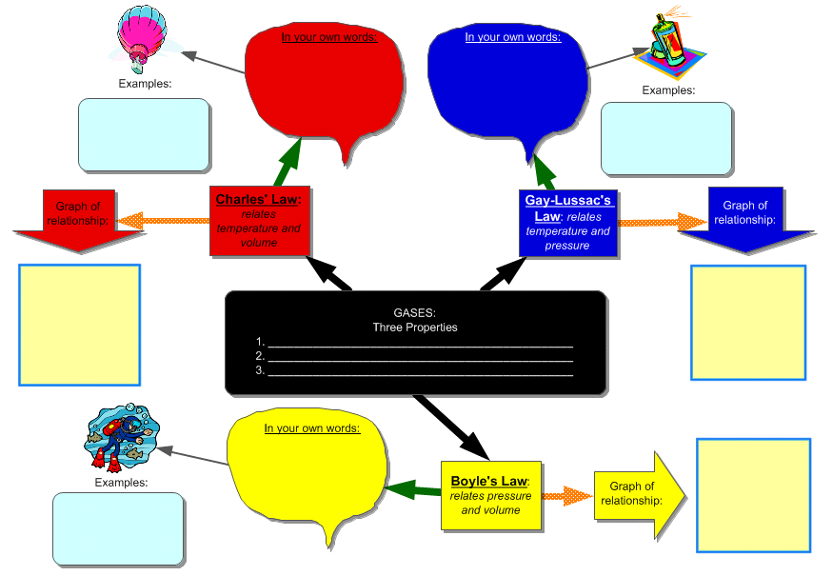

Elaborate/Extend: How can they apply this? Demonstrate learning.

Students will list out and explain examples of each of the three gas laws. This will demonstrate that they understand the laws well enough that, using this chart, their recent observations, and informational texts, they are able to apply their new knowledge to different situations. Creating graphs that correctly represent the relationship between variables will also demonstrate learning by the students.

Evaluate: How much progress have they made?

In evaluating students’ progress for this lesson, I will be primarily looking at their completed concept maps. A correctly completed map will include a correct explanation of each law in the student’s own words (not the one from the back of the book). A completed map will also include graphs of the relationship between each of the variables. I will be looking to see that each axis on the graph is labeled and that the slope of the line is correct.

I will also have students turn in their observations from each station to ensure that the conclusions they came to on their concept map are based on the data they collected during their exploration.

The student should have:
-recorded observations from each station
-explanation of each law in their own words
-examples (more than one) of each law
-graphs with correctly labeled axes and a correct slope on the lines
Here is what a correctly completed concept map should look like:
