Walker, Physics, 3rd Edition
Chapter 2
Conceptual Questions
(The effects of air resistance are to be ignored in this chapter.)
1. You and your dog go for a walk to a nearby park. On the way, your dog takes many short side trips to chase squirrels, examine fire hydrants, and so on. When you arrive at the park, do you and your dog have the same displacement? Have you traveled the same distance? Explain.
2. Does an odometer in a car measure distance or displacement? Explain.
3. Can you drive your car in such a way that the distance it covers is (a) greater than, (b) equal to, or (c) less than the magnitude of its displacement? In each case, give an example if your answer is yes, explain why not if your answer is no.
4. An astronaut orbits Earth in the space shuttle. In one complete orbit, is the magnitude of the displacement the same as the distance traveled? Explain.
5. After a tennis match the players dash to the net to congratulate one another. If they both run with a speed of 3 m/s, are their velocities equal? Explain.
6. Does a speedometer measure speed or velocity? Explain.
7. Is it possible for a car to circle a race track with constant velocity? Can it do so with constant speed? Explain.
8. Friends tell you that on a recent trip their average velocity was Is it possible that their instantaneous velocity was negative at any time during the trip? Explain.
9. For what kind of motion are the instantaneous and average velocities equal?
10. If the position of an object is zero, does its speed have to be zero? Explain.
11. Assume that the brakes in your car create a constant deceleration, regardless of how fast you are going. If you double your driving speed, how does this affect (a) the time required to come to a stop, and (b) the distance needed to stop?
12. The velocity of an object is zero at a given instant of time. (a) Is it possible for the object’s acceleration to be zero at this time? Explain. (b) Is it possible for the object’s acceleration to be nonzero at this time? Explain.
13. If the velocity of an object is nonzero, can its acceleration be zero? Give an example if your answer is yes, explain why not if your answer is no.
14. Is it possible for an object to have zero average velocity over a given interval of time, yet still be accelerating during the interval? Give an example if your answer is yes, explain why not if your answer is no.
15. A batter hits a pop fly straight up. (a) Is the acceleration of the ball on the way up different from its acceleration on the way down? (b) Is the acceleration of the ball at the top of its flight different from its acceleration just before it lands?
16. A person on a trampoline bounces straight upward with an initial speed of 4.5 m/s. What is the person’s speed when she returns to her initial height?
17. After winning a baseball game, one player drops a glove, while another tosses a glove into the air. How do the accelerations of the two gloves compare?
18. A volcano shoots a lava bomb straight upward. Does the displacement of the lava bomb depend on (a) your choice of origin for your coordinate system, or (b) your choice of a positive direction? Explain in each case.
Conceptual Exercises
(The effects of air resistance are to be ignored in this chapter.)
2. You drive in a straight line at 15 m/s for 10 kilometers, then at 25 m/s for another 10 kilometers. Is your average speed for the entire trip (a) 20 m/s, (b) more than 20 m/s, or (c) less than 20 m/s?
4. Two bows shoot arrows with the same initial speed. The string in bow A must be pulled back farther when shooting its arrow than the string in bow B. Is the acceleration of the arrow shot by bow A (a) greater than, (b) less than, or (c) equal to the acceleration of the arrow shot by bow B?
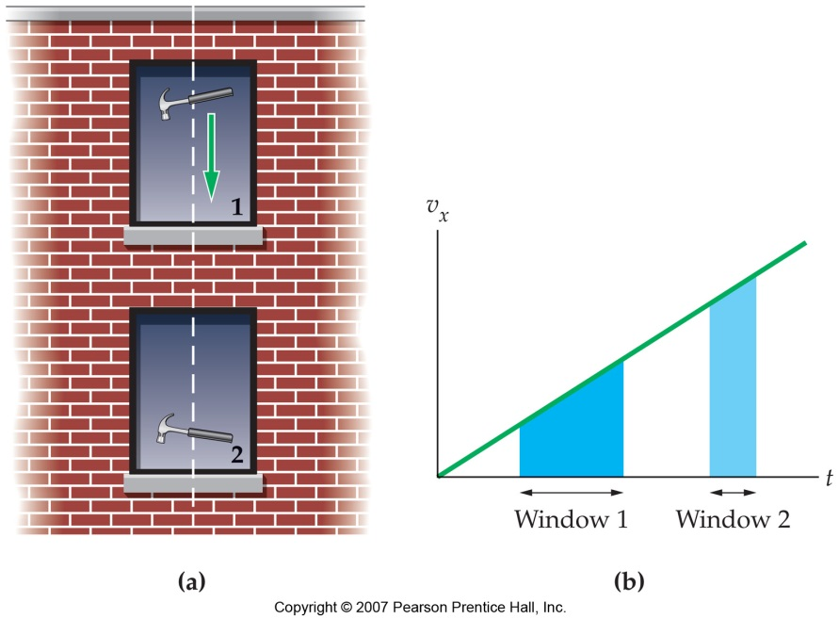
6. A carpenter on the roof of a building accidentally drops her hammer. As the hammer falls, it passes two windows of equal height, as shown in Figure 2–22 (a). Is the increase in speed of the hammer as it drops past window 1 (a) greater than, (b) less than, or (c) equal to the increase in speed as it drops past window 2?
8. At the edge of a roof you throw ball A upward with an initial speed of and then throw ball B downward with the same initial speed. Just before the balls hit the ground, which of the following is true: (a) the speed of ball A is greater than the speed of ball B, (b) the speed of ball A is equal to the speed of ball B, or (c) the speed of ball A is less than the speed of ball B?

